**Life Cycle**

Life Cycle “V”

The model in V is a variation of the model in cascade that shows how they relate the test activities with the analysis and the design. As the picture shows, the coding forms the vertex of the V, with the analysis and the design on the left and tests and maintenance on the right. The union by broken lines between the phases of the left part and the tests of the right represents a double information. On the one hand it serves to indicate in which phase of development the corresponding tests must be defined. For another serves to know to which phase of development it is necessary to return to if there are faults in the corresponding tests.

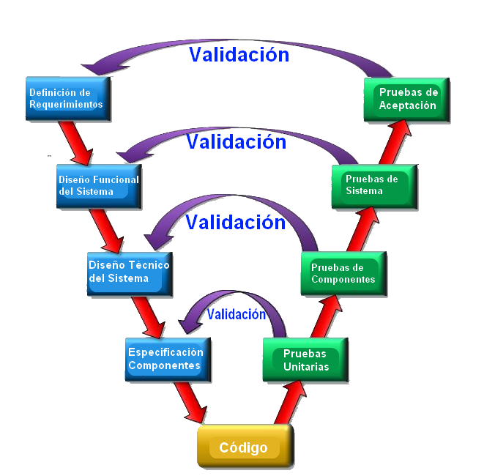

Figure 1. Life Cycle “V”.

Phases

* Analysis
  + Data collection.
  + Examine the data.
  + Formulate the client’s requirements.
* Design

Technical design of the system

* + - General design of the application architecture
  + Functional design of the system
    - Diseño a detalle de las partes que conformen la aplicación.
    - Detailed design of the parts that make up the application.
* Check
  + Evaluation of the system or components to determine that the previous phases meet their requirements.
  + Review of what was imposed in the analysis with what has been obtained so far.
* Programming
  + Project coding
  + Identification of errors when coding
  + Debugging of the errors in coding
* Test
  + Unit tests
    - Specialized test execution plans
    - Identification of errors when coding
  + Component tests
    - Test of each section of the site.
    - Debugging of the errors in coding
  + System tests
    - General testing by stakeholders
    - Test of compatibility with systems and performance.
  + Acceptance tests
    - Implementation to the client
    - Test of operation by the client
* Maintenance
  + Correction of errors of use
  + Adaptation to the use of the client
  + Modification of the software for better functioning

**Advantage:**

• The relationship between the stages of development and the different types of tests facilitate the location of faults.

• It is a simple and easy to learn model.

• Explicit part of the iteration and work to be reviewed.

• Specify well the roles of the different types of tests to be performed.

• Involves the user in the tests.

**Disadvantage:**

* It is difficult for the client to explicitly state all the requirements.

• The client must have patience because he will obtain the product at the end of the life cycle.

• Tests can be expensive and, sometimes, not effective enough.

• The final product obtained may not reflect all the user's requirements.

**Justification for the use of the life cycle**

For the choice of the life cycle we based on the requirements that had been presented to us by the clients, the time we have for the realization of the project, the necessary roles for the satisfactory completion, as well as the skills and abilities of each one. of the members that we have in our work team, since when reviewing the curricula and seeing what skills we each have, we were able to assign the possible roles to be played; Once having the possible roles, we got together to review the requirements that were asked of us in the project, since having those determining elements of the project, we could determine which is the most efficient way to work.

On the other hand, the choice of the life cycle in V was due to the way in which each of the work phases that make it up is carried out, since this life cycle is based on the structure of the life cycle in cascade, without However, it has the benefit that each section that is being prepared has or can have a section where it can be revised, making it possible to revise, correct or implement improvements to the previous one without interfering fully in the new phase that is being developed. Since only the necessary changes that have been detected as necessary will be made.

In addition to having many test sections, which favors a little more thorough review of each section or development phase by both the developer team and the client, so that when the system test arrives and the implementation in the work area of the client, do not run into failures, errors or need changes for not taking into account the functionality or the point of view of the client for its better and easier handling.

Finally, another factor that helped us determine this life cycle as indicated for us was its effectiveness in the development of the projects, because in the companies that use it, there is always efficiency and full compliance with what is required. In addition to this life cycle requires compliance with the activities in time and form by the same fact that is going through each phase to check their relationship with the requirements.